**WEEK-2**

**PL/SQL Exercises:**

**Exercise 1: Control Structures**

1. Creating Customers and Loans table

CREATE TABLE CUSTOMERS (

CustID NUMBER PRIMARY KEY,

Name VARCHAR2(100),

Age NUMBER,

Balance NUMBER(10,2),

IsVIP VARCHAR2(5)

);

CREATE TABLE LOANS (

LoanID NUMBER PRIMARY KEY,

CustID NUMBER,

InterestRate NUMBER(5,2),

DueDate DATE,

FOREIGN KEY (CustID) REFERENCES CUSTOMERS(CustID)

);

1. Inserting data(here I have added the sample data..actual data differs)

INSERT INTO CUSTOMERS VALUES (1, 'Alice', 65, 12000, 'FALSE');

INSERT INTO CUSTOMERS VALUES (2, 'Bob', 45, 8000, 'FALSE');

INSERT INTO CUSTOMERS VALUES (3, 'Charlie', 70, 9500, 'FALSE');

INSERT INTO CUSTOMERS VALUES (4, 'Diana', 30, 15000, 'FALSE');

INSERT INTO LOANS VALUES (101, 1, 10.5, SYSDATE + 10);

INSERT INTO LOANS VALUES (102, 2, 11.0, SYSDATE + 40);

INSERT INTO LOANS VALUES (103, 3, 9.5, SYSDATE + 20);

INSERT INTO LOANS VALUES (104, 4, 8.0, SYSDATE + 5);

COMMIT;

**Scenario 1:** The bank wants to apply a discount to loan interest rates for customers above 60 years old.

**Question:** Write a PL/SQL block that loops through all customers, checks their age, and if they are above 60, apply a 1% discount to their current loan interest rates.

BEGIN

  FOR rec IN (

    SELECT l.LoanID, l.InterestRate

    FROM LOANS l

    JOIN CUSTOMERS c ON l.CustID = c.CustID

    WHERE c.Age > 60

  )

  LOOP

    UPDATE LOANS

    SET InterestRate = rec.InterestRate - 1

    WHERE LoanID = rec.LoanID;

  END LOOP;

  COMMIT;

END;

/

**Scenario 2:** A customer can be promoted to VIP status based on their balance.

**Question:** Write a PL/SQL block that iterates through all customers and sets a flag IsVIP to TRUE for those with a balance over $10,000.

BEGIN

  FOR rec IN (

    SELECT CustID FROM CUSTOMERS WHERE Balance > 10000

  )

  LOOP

    UPDATE CUSTOMERS

    SET IsVIP = 'TRUE'

    WHERE CustID = rec.CustID;

  END LOOP;

  COMMIT;

END;

/

**Scenario 3:** The bank wants to send reminders to customers whose loans are due within the next 30 days.

**Question:** Write a PL/SQL block that fetches all loans due in the next 30 days and prints a reminder message for each customer.

SET SERVEROUTPUT ON;

BEGIN

  FOR rec IN (

    SELECT c.Name, l.DueDate

    FROM LOANS l

    JOIN CUSTOMERS c ON l.CustID = c.CustID

    WHERE l.DueDate BETWEEN SYSDATE AND SYSDATE + 30

  )

  LOOP

    DBMS_OUTPUT.PUT_LINE('Reminder: Dear ' || rec.Name ||

                         ', your loan is due on ' || TO_CHAR(rec.DueDate, 'DD-Mon-YYYY'));

  END LOOP;

END;

/

**Output:**

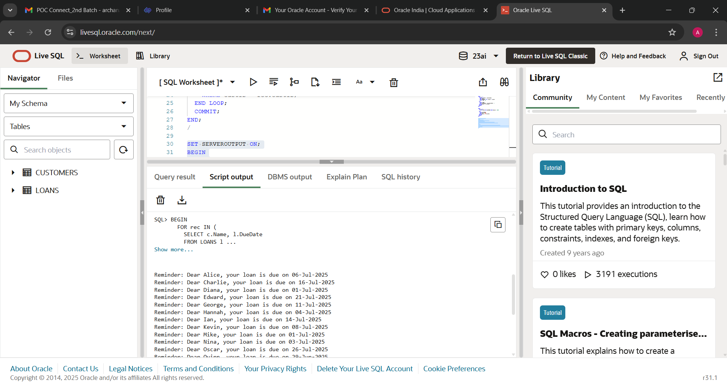

CUSTOMERS TABLE:

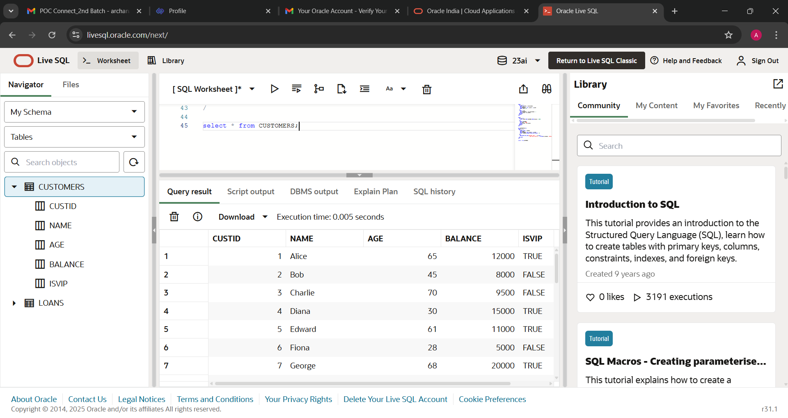

LOANS TABLE:

